ACCELERATION

Acceleration (a): rate of change of velocity in a given direction.

It is a vector quantity and is calculated by the equation:

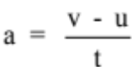

where a = acceleration in a given direction (ms⁻²)
u = initial velocity of the object (ms⁻¹)
v = final velocity of the object (ms⁻¹)
t = time taken for the change in velocity to occur (s)

Note
• When solving problems, pick one direction as the positive direction.

• Any vector in this direction is a positive value.

• Any vector in the opposite direction is a negative value.

Examples

1. A car moving at 30.0 kmh⁻¹ east accelerates uniformly to 70.0 kmh⁻¹ east in 12.0 s.
Calculate the acceleration experienced.

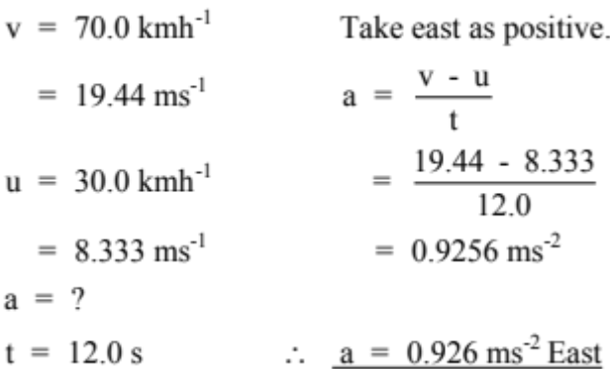

2. A car moving at 70.0 kmh⁻¹ along a straight road brakes suddenly to avoid a dog that
ran onto the road. It reduced its velocity to 15.0 kmh⁻¹ in 2.97 s and successfully
missed the animal. Calculate the deceleration of the car.

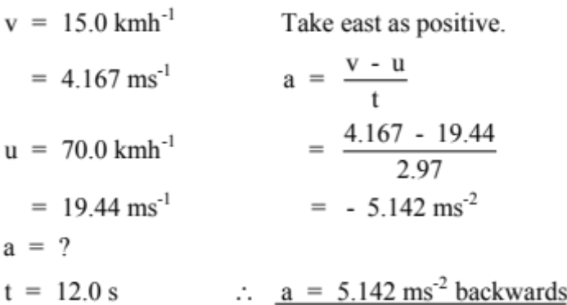

Note

The negative answer to the above example indicates that the acceleration is in the opposite direction to the direction chosen as positive (i.e. backwards).

Hence deceleration is an acceleration in the backwards direction, causing the car to slow.

If any answer to a problem is negative (and you are sure of your mathematics!), it means the vector is acting in the opposite direction to the positive direction you chose.

EQUATIONS OF MOTION

There are three equations which describe the relationship between acceleration, displacement, initial and final velocity and time.

They are as follows.

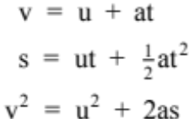

where v = final velocity (ms⁻¹)
u = initial velocity (ms⁻¹)
a = acceleration (ms⁻²)
t = time (s)
s = displacement (m)

These equations apply only for acceleration occurring in one dimension.

This can be for cars, bikes and other objects moving horizontally across the ground or for objects accelerating vertically under the influence of gravity.

Gravity accelerates all objects down towards the centre of the Earth at 9.80 ms⁻² at the
surface.

Examples

1. A car accelerates uniformly from rest at 3.56 ms-2 and reaches a velocity of 25.0 ms⁻¹.
Calculate:

(a) how far the car moves during this time.
(b) the time taken for the motion.

(a)
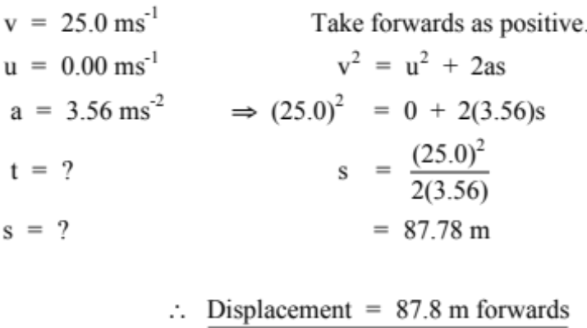

(b)
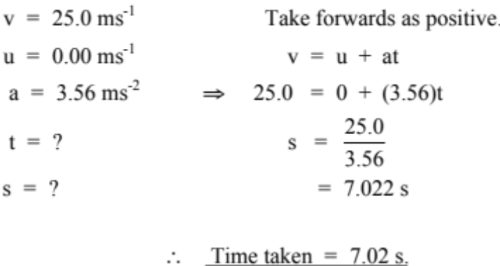

2. A ball rolls off a table 1.45 m high and lands on the floor. Calculate:

(a) the time of flight.
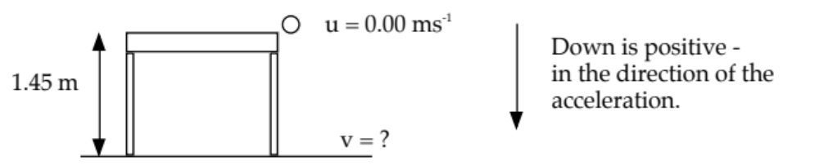
(b) the velocity with which it hits the floor.

(a)
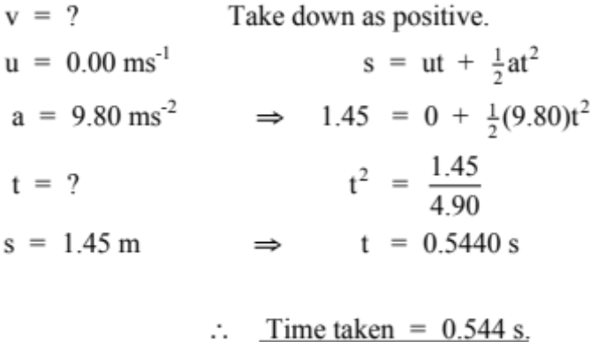

(b)
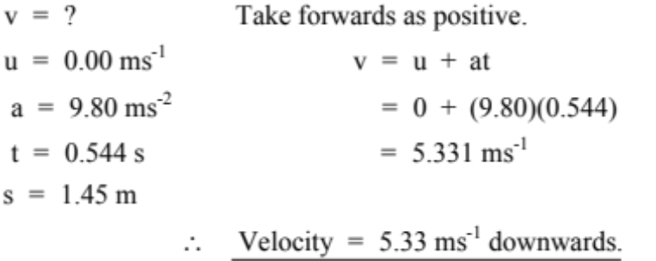

3. A boy kicks a football vertically upwards at 15.0 ms⁻¹ from 0.500 m above the ground.
The ball moves above the height of a nearby tree and gets caught by a branch 4.00 m
above the ground.

(a) Calculate the maximum height reached by the ball.
(b) Determine the velocity of the ball when it is caught by the tree.
(c) How long is the ball in flight?

(a)
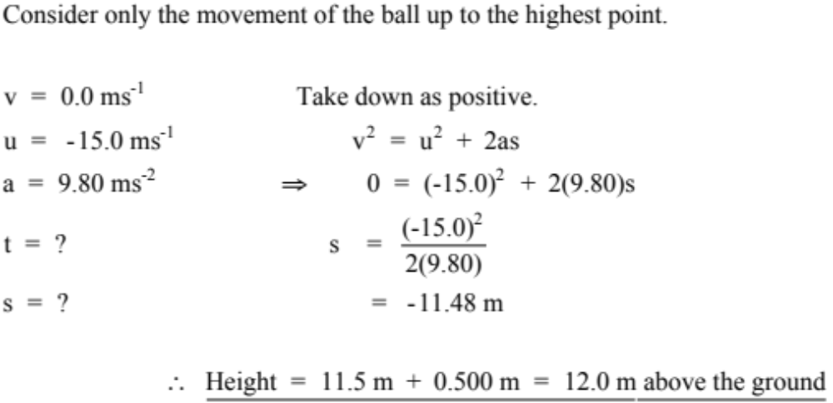

(b)
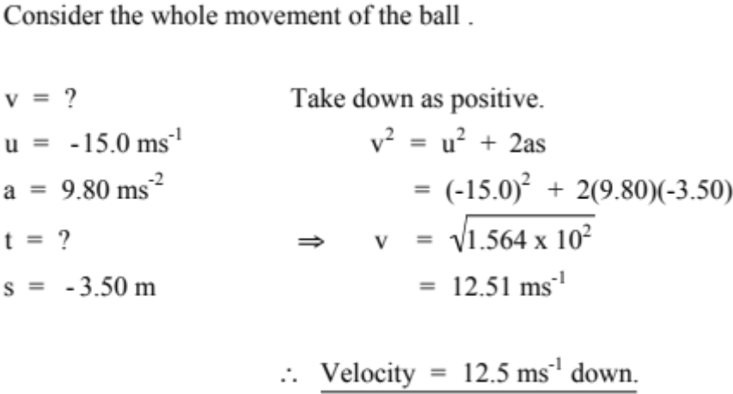

(c)
